**SI Project**

**Bing Web Search API:**

Bing Web search API is a cloud based API which provides search engine services.

The aim of this document is to introduce a nodejs app that makes use of Bing web search API to provide search engine services.

**Prerequisites for running this app :**

* An Azure subscription  [Follow](https://azure.microsoft.com/free/cognitive-services/) this [link](https://www.microsoft.com/en-us/bing/apis/bing-web-search-api) to get subscription
* Once you have your Azure subscription, [create a Bing Search resource](https://portal.azure.com/#create/Microsoft.CognitiveServicesBingSearch-v7) in the Azure portal to get your key and endpoint.
* Node.js 8 or later

**Components of the app**

* bing-web-search.js  is the Express.js app. It handles request/response logic and routing.
* public/index.html – This is html file for representing the app
* public/css/styles.css - Defines page styles, such as fonts, colors, text size.
* public/js/scripts.js - Contains the logic to make requests to the Bing Web Search API, manage subscription keys, handle and parse responses, and display results.

**HTML page (**public/index.html**):**

The index.html includes a form that enables users to search and select search options.

The **onsubmit** attribute triggers when the form is submitted,

The onsubmit attribute calls the bingWebSearch() method defined in scripts.js. It takes three arguments:

* Search query
* Selected options
* Subscription key



**Script.js(**public/js/scripts.js **):**

**getSubscriptionKey():**

The getSubscriptionKey() function uses the storeValue and retrieveValue functions to store and retrieve a user's subscription key. These functions use the localStorage object, if supported, or cookies.

Method checks if the subscription key is stored with in the local storage of the server.

If the key is already stored , then it proceeds return the key. Else it will prompt for key.

**bingSearchOptions()**

The bingSearchOptions() function converts options to match the format required by the Bing Search API

**Few of the options are :**

mkt – defines the region of search results

SafeSeach – defines whether he search results are strict or moderate

Count – no of search results

**All other options can be found** [**here**](https://docs.microsoft.com/en-us/bing/search-apis/bing-web-search/reference/query-parameters)

**bingWebSearch()**

Given the query, the options string, and the subscription key, the BingWebSearch function creates an XMLHttpRequest object to call the Bing Web Search endpoint. And sends the request if successful.

**renderResultsItems()**

The renderResultsItems() function iterates through the items in each RankingResponse collection , maps each ranking result to a search result using the answerType and resultIndex values, and calls the appropriate rendering function to generate the HTML.

If resultIndex isn't specified for an item, renderResultsItems() iterates through all results of that type and calls the rendering function for each item. The resulting HTML is inserted into the appropriate <div> element in index.html.

**Running Screenshots:**

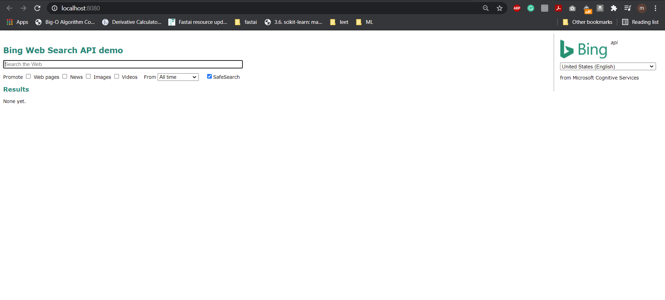

**Running for the first time on the server. If subscription key is not stored locally.**

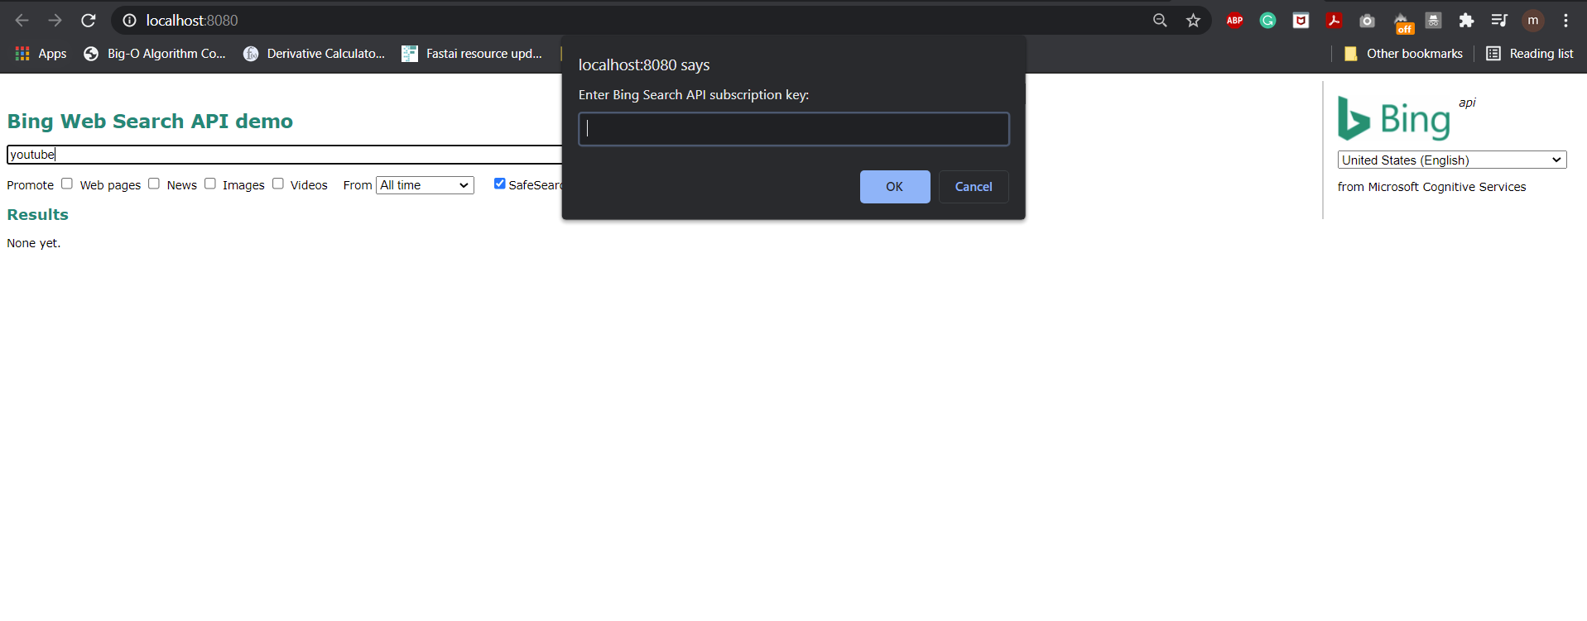

**Search results for input “Youtube”**

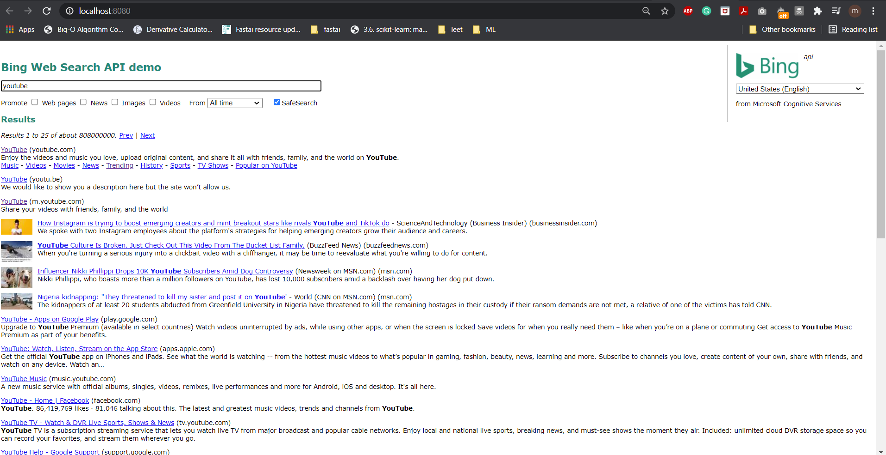

**Postman**

